Guidelines for application letter and company information

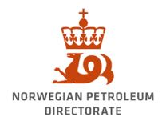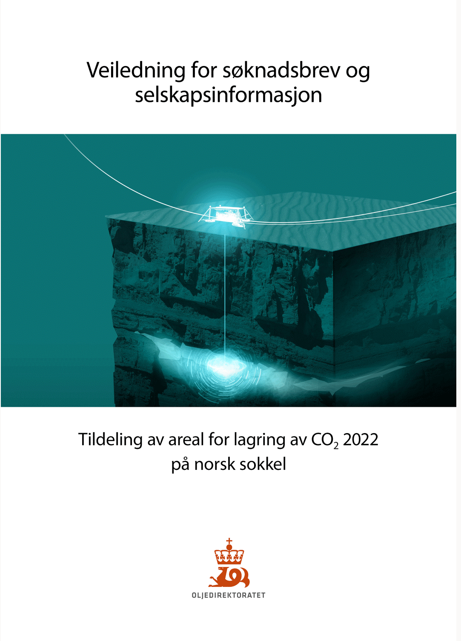

Award of area for storage of CO2 2023-1  
on the Norwegian continental shelf

Table of Contents

Submitting application letters and company information 3

1. Application letter from company 3

1.1 Applicant and contacts 3

1.2 Application list 4

1.3 Maps of the applied-for acreage 4

1.4 Review of application(s) 4

1.5 Appendix – receipt for paid application fee 4

2. Company information 5

2.1 The company's ownership structure, organisation and experience 5

2.2 The company's planned business model 5

2.3 The company's financial situation 5

# Submitting application letters and company information

A formal application letter with an overview of the applications the company is involved in, both individually and as a participant in group applications, must be submitted along with the company information, and the receipt for payment of the application fee in a dispatch to the Ministry of Petroleum and Energy (MPE), the Norwegian Petroleum Directorate (NPD) and the Petroleum Safety Authority (PSA). If submitting via L2S Authority Communication, both the MPE and NPD can be chosen as recipients of the same dispatch.

Submission to the NPD

Place the files in a folder named *CO2-2023-1-"companyname"-applicationletter,* and then compress the folder ("zip format"). There must be no sub-folders and the zip file must not be password-protected. Example for company "CCS AS": CO2-2023-1-CCS AS-applicationletter.zip

Title the dispatch *CO2-2023-1-"companyname"*-*applicationletter* and submit it via L2S Authority Communication or via Altinn to the Norwegian Petroleum Directorate.

Submission to the MPE

The files must be submitted to the Ministry of Petroleum and Energy (MPE) via L2S Authority Communication or via Altinn.

It is recommended to submit the files in good time before the application deadline.

A receipt will be issued for the received application letter and company information. Please note that some processing time must be expected. To receive a receipt immediately, list yourself as the receipt recipient in the "Receipt" field when using L2S Authority Communication.

The files must be named as reflected below:

|  |  |  |
| --- | --- | --- |
| **File name** | **Format** | **Description** |
| ApplicationLetter_"CompanyName" | .pdf | Application letter |
| CompanyInformation_"CompanyName" | .pdf | Company information |
| CompanyInformation | .xlsx | The Excel workbook "CompanyInformation" |
| ApplicationFee | .pdf | Receipt for paid application fee |
| AnnualReport_"CompanyName" | .pdf | Annual report |
| QuarterlyAccounts_"date" | .pdf | Most recent quarterly accounts |

# Application letter from company

A formal application letter with an overview of all the applications the company is involved in, both individually and as a participant in group applications, must be submitted to the MPE with copies to the NPD and PSA within the application deadline. The application letter must contain the following:

## 1.1 Applicant and contacts

State the company's name, address and nationality, as well as the contacts' names, titles, telephone numbers and e-mail addresses. At least two contacts should be available in Norway for the Norwegian authorities throughout the entire application period up until award.

## 1.2 Application list

List the applications in prioritised order and include information about the proposed operator and distribution of ownership interests. Table 5: "Application list from company" can be used. Table 5 can be found in the Excel workbook CompanyInformation. The form can be filled out in Norwegian or English in fields without a dropdown menu option. Additional rows can be added to the form.

## 1.3 Maps of the applied-for acreage

Indicate the applied-for acreage and an outline of the mapped storage complexes shown in the maps with geographical coordinates, block numbers and a scale for applications the company is submitting itself. For applications for stratigraphic permits, list the relevant stratigraphic intervals.

## Review of application(s)

Give a brief summary of each application, including project description. Include comments on priority, listed ownership interests and the proposed operator, as well as other factors the applicant wants to highlight, for example strategic aspects.

## Appendix – receipt for paid application fee

A scanned copy of the receipt must be enclosed with the application letter as a separate file. Mark the file *"ApplicationFee".* If the company is participating in a group application and the fee was paid by another group member on behalf of the group, this must be indicated by ticking off a box in the application form.

# Company information

Information about each individual company applying, or companies that are participating in a group application must be submitted to MPE within the application deadline. Companies submitting an application on behalf of a group must make the other companies in the group aware that each company must submit such information.

**Company information form:**

*The Excel workbook "CompanyInformation"*" contains all the tables mentioned below. The form can be filled out in Norwegian or English in fields where there is no dropdown menu.

Table 6: The company's size and experience

Table 7: The company's financial situation

Table 8: The company's expected cash flow (only for companies without a financial credit rating)

## 2.1 The company's ownership structure, organisation and experience

Provide an overview of the company's ownership structure with a list of the most important owners/owner groups and their ownership interest. Information is also requested about where the company is registered, the company's headquarters, as well as the composition of the board, including the board members' place of residence and nationality.

Provide a status on the company's organisation in Norway at the time of application. The overview must document the company's expertise and capacity. Attach an organisation chart showing the company's own employees. Only include company personnel in positions that are currently filled. All consultants must also be included in the overview.

Information about the company's size and experience with CO2 storage on the Norwegian Continental Shelf or equivalent relevant experience from other areas, including experience with developing and operating storage locations for CO2, oil and gas fields or geological gas storage reservoirs.

Please limit this account to no more than three pages of text.

## 2.2 The company's planned business model

The applicant must document that awarding a new permit is a prerequisite for implementing and/or further developing specific, profitable projects for capture, transport and storage of CO2. In addition to a sufficient geological understanding of the area, the applicant must have satisfactory expertise and financial resources to manage the activity.

Profitability calculations with preconditions (tariffs, discount rate and CO2 price assumptions) must be presented for relevant solutions, with plans and status of any agreements for access to CO2 for storage. Please briefly address any plans for commercial negotiations.

Please limit this documentation to no more than three pages of text.

## 2.3 The company's financial situation

Documentation of the company's financial capacity must be provided, with the following reporting for different categories of companies:

1. **Companies with a financial credit rating**

Companies that have a financial credit rating from international credit rating agencies must list this in the form "*Table 7: Financial status*" along with financial key figures. The form must be submitted as part of the Excel workbook *"CompanyInformation".*

1. **Companies without a financial credit rating**

In addition to filling out *"Table 7: Financial status"*, which must be submitted in the Excel workbook *"CompanyInformation"*, companies without a financial credit rating from international credit rating agencies must report the following:

* explain how they plan to handle the financial obligations that are presumed to follow from a potential award
* include their annual report as well as the most recent quarterly report in pdf format. If relevant, provide annual reports for both the Norwegian company and the parent company/group
* If the company conducts a significant share of its activities on the Norwegian shelf, the following must also be reported:
  + explain the overall planned financial obligations and how they will be covered for three years moving forward
  + which other obligations the company has in its portfolio associated with CCS
* provide detailed comments on the capital structure. This explanation should address the sources of debt (bank, bonds, parent company, etc.) and the sources of potential new equity (parent company, stock exchange, etc.). Please list the term of the company's loans.
* fill out the form *"Table 8: Projected cash flow"* in the Excel workbook *"CompanyInformation",* which shows the projected cash flow for the Norwegian company

We recommend limiting this part/chapter to up to five pages.

If the company is part of an international corporation, the information in the form *"Table 7: Financial status"* should refer to the entire group. Please specify whether the information in the form concerns figures for the company or for the entire group in the comment field under *"Table 7: Financial status"*.

If there are any special circumstances that may affect the company's financial ability to fulfil its current or future obligations concerning the activities on the Norwegian shelf, please explain these circumstances.